Student’s name | …………………………………………………….…… | Grade | 5
Subject | Computer | Week No. | 6
Lesson Title | Smart Art, Hyperlinks in PPT | Unit
Worksheet No. ( 6 ) (Answer)

Question A: Write the correct name of each part.

Quick access toolbar | Titlebar | Ribbon Menu

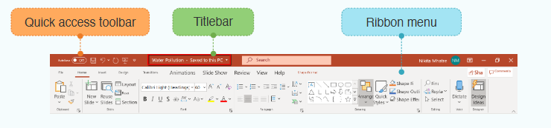
Quick access toolbar
Titlebar
Ribbon Menu

Good Luck

